Automatic Hand Sanitizer Dispenser

Description:
The Automatic Hand Sanitizer Dispenser is a contactless hygiene system designed to dispense sanitizer automatically when a hand is detected.
This project helps reduce physical contact and prevents the spread of germs.
It uses an ultrasonic sensor to detect the presence of a hand and a servo motor to press or release the sanitizer container mechanism.
Block Diagram:
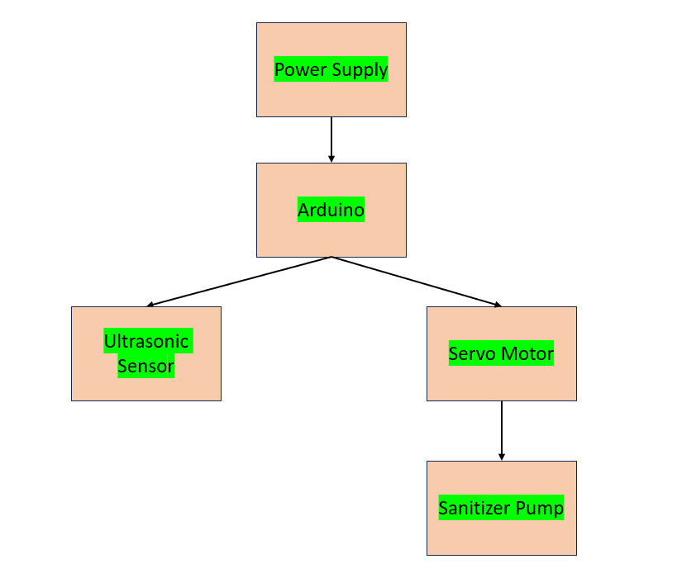

Pinout / Circuit Connection:
Ultrasonic Sensor TRIG → Arduino Pin 9
Ultrasonic Sensor ECHO → Arduino Pin 10
Ultrasonic Sensor VCC → 5V
Ultrasonic Sensor GND → GND
Servo Motor Signal → Arduino Pin 6
Servo Motor VCC → 5V
Servo Motor GND → GND
Power Supply: 9V Battery (connected to Arduino VIN)

Components Required:
Arduino Uno / Nano
Ultrasonic Sensor (HC-SR04)
Servo Motor (SG90 or equivalent)
9V Battery
Hand Sanitizer Container
Jumper wires
Breadboard
Working Principle:
The project works on the principle of ultrasonic distance measurement.
The ultrasonic sensor emits high-frequency sound waves and measures the time taken for the echo to return.
When a hand is placed within a predefined distance, the Arduino detects it.
The Arduino then rotates the servo motor, which presses the sanitizer container to dispense sanitizer.
After a short delay, the servo returns to its original position.

Operation (Step-by-Step):
- Mount the ultrasonic sensor near the sanitizer outlet.
- Connect all components as per the circuit diagram.
- Upload the Arduino code to the board.
- Power ON the system using a 9V battery.
- When a hand comes close to the sensor, distance reduces.
- Arduino detects the hand and activates the servo motor.
- Servo motor presses the sanitizer container.
- Sanitizer is dispensed automatically.
- Servo returns to its initial position.

Arduino Code:
#include <Servo.h>

Servo myServo;

int trigPin = 9;
int echoPin = 10;
int servoPin = 6;

long duration;
int distance;

void setup() {
pinMode(trigPin, OUTPUT);
pinMode(echoPin, INPUT);
myServo.attach(servoPin);
myServo.write(0); // Initial position
}

void loop() {
digitalWrite(trigPin, LOW);
delayMicroseconds(2);
digitalWrite(trigPin, HIGH);
delayMicroseconds(10);
digitalWrite(trigPin, LOW);

duration = pulseIn(echoPin, HIGH);
distance = duration * 0.034 / 2;

if (distance > 0 && distance < 10) { // Hand detected
myServo.write(90); // Press container
delay(1000);
myServo.write(0); // Release
}

delay(500);
}
Conclusion: (Predefined/self-written)
The Automatic Hand Sanitizer Dispenser using Arduino, ultrasonic sensor, and servo motor demonstrates an effective contactless automation system.
It promotes hygiene and safety in public places and provides a practical example of sensor-based control systems.
For Your References:
[1] Arduino, Ultrasonic Sensor with Arduino, Arduino.cc
[2] Electronics Hub, “Automatic Hand Sanitizer Dispenser using Arduino,” Electronicshub.org, 2023. [Online]. Available: https://www.electronicshub.org/automatic-hand-sanitizer-dispenser/. [Accessed: 27-Aug-2025].

